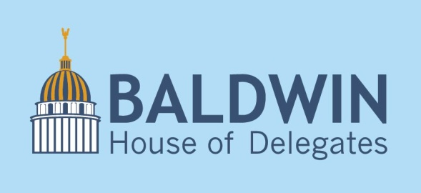

Senate Passes “Right to Work”
January 22, 2016

Yesterday, the Senate passed so-called “Right to Work” legislation by a vote of 17-16. This came after a contentious floor debate, including Sen. Robert Karnes calling union members present in the gallery “freeloaders.”

Senate President Bill Cole and House Speaker Tim Armstead both support the legislation by arguing it’s a vital step in moving the economy forward. However, studies are decidedly mixed on the economic effects of “Right to Work.”

If moving the economy forward is our goal—and it should be because our quality of life has languished behind other states for far too many years—is this really our best solution? Are employers more likely to create jobs here in West Virginia if we mark a box calling ourselves a “Right to Work” state, which also hurts the section of the labor force that has been most hurt by changing market conditions? I don’t think so.

I talk to employers all the time about what they want, and it has nothing to do with “Right to Work.” They want good workers who provide for their families and enrich the community. They want quality schools, healthy citizens, a beautiful landscape, actual broadband internet, reliable roads, and safe communities.

Economic development is not rocket science. Proven strategies work. “Right to Work” is not one of them. It’s a divisive issue that has little economic value. That’s why I oppose it. We should be spending our valuable legislative time on issues that will positively affect the economy. If we invest wisely in our people and our land, our economy will reap the benefits.

